Bhil art: Tribal paintings from india
Tribal art has been gaining popularity in recent years due to the rich cultural heritage it reflects and the bold creations it results in. In a previous post, we discussed Gond art in celebration of the first Indian Folk and Tribal Art Auction held at Saffronart. After with the Gonds, the Bhils are the second largest tribal community in western and central India. Their art focuses on their natural environment filled with songs, rituals, tattoos and folklore. In a new collection on The Story by Saffronart called Rhythms and Rituals, we’re featuring some fantastic pieces from celebrated Bhil artists.
The tradition of Bhil painting first stemmed from the home. Upon visiting a Bhil household, one will discover a delightful myriad of images from myth and folklore adorning their walls and ceilings. Every year, a new plaster of mittichitra (clay relief work) and paintings are applied to the interiors of the house. Pigments are ground from natural materials and leaves and flowers, while brushes are made with neem twigs.
Pithora horses are a common theme among Bhil artists. The traditional painter or lekhindra often paints pithoras as an offering to the goddesses. According to legend, the people of the Kingdom Dharmi Raja have forgotten how to laugh. The brave prince Pithora rode on horseback through a dangerous terrain and brought back laughter and joy from the goddess Himali Harda. Similar to all adivasi tribes, the Bhils live close to nature and lead a largely agricultural life. Their paintings reflect the changing seasons, the natural phenomena that guide their harvest, and the gods that protect them.
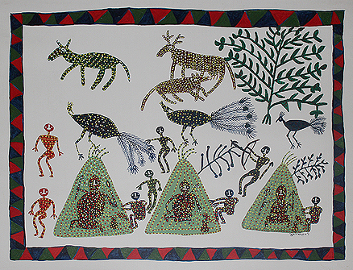
Subhash Bheel
Untitled
The Story by Saffronart
Bhuri Bai of Zher is one of the leading Bhil artists of our time. She started painting at a young age when the colors at a local festival inspired her to paint laughing goddesses and everyday scenes from the village. Her mother taught her how to make huts and decorate them with cows that became a prominent symbol in her work. In her adult life, she transferred the paintings from mud to paper and canvas, and continues to decorate the walls at the Museum of Mankind in Bhopal.
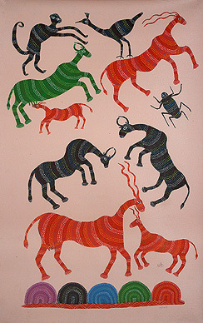
Lado Bai
Untitled
The Story by Saffronart
Another prominent artist is Lado Bai whose art reflects the spirituality and animism of her community. For years, she could not pursue her art because of financial constraints. Her luck turned when she was discovered by the famous Indian artist Jagdish Swaminathan. Swaminathan encouraged her to work for the Adivasi Lok Kala Academy where she had the opportunity to transfer images of festivals, rituals and animals from wall to paper.
Bhil artists are just starting to be internationally recognized. They paint the simple human joys of birth and other ceremonial occasions like harvests that are often forgotten in our modern society. The art of the Bhils along with that of other tribal groups reminds us what the simple pleasures in life are.

Source: blog.saffronart.com

